**Pre-test Pokémon in the lab**

**Instructions**

**Purpose:**

To choose neutral and unfamiliar Pokémon characters to use as stimuli in a replication project (i.e., a replication of the surveillance task used by Olson & Fazio, 2001).

**Procedure:**

20 pictures of Pokémon (image + name) were presented in a random order. The 20 Pokémon were chosen from generations 4-7 to decrease the chances that they will be familiar to participants (see images below) and based on an initial pretest in which 60 pictures of Pokémon were pretested online with a separate sample of 155 participants via the Prolific Academic website (https://prolific.ac) along two dimensions: valence and familiarity. On the basis of this pretest, we selected 20 characters which were rated most neutrally and at least familiar.

**Instructions in the beginning (translated from Dutch):**

*Welcome to the experiment! Thank you for taking part.*

*In this task, we are going to present you pictures of different creatures.*

*Please indicate how positive or negative you consider the creature to be, and how familiar are you with it.*

**Ratings**

Participants rated each Pokémon character on two scales (presented on the same screen, the valence question above the familiarity question):

1. *Please rate how positive or negative this creature is using the scale below*

SCALE: -4 = very negative, 0 = Neutral, 4 = very positive

2. *Please rate how familiar are you with this creature is using the scale below*

SCALE: 0 = Not Familiar at all, 8 = Very Familiar

**Participants:**

Each lab will ideally collect data from 71 participants. This sample size will provide 80% power to detect a small effect (d=0.3).

**Planned Analysis:**

Mean liking score and mean familiarity score for each character will be computed.

1. Based on effect size and Bayes-Factor analyses on the above ratings, select the 9 characters that are rated closest to 0 (neutral) on the liking scale.

2. Then, make sure that they are not rated as somewhat familiar (i.e., that they rated significantly below 4 on the familiarity scale).

3. Thereafter, please identify, which two of the nine characters are most neutral and least familiar.

• Don’t choose WIMPOD or GURBBIN as CSs (they can be targets or fillers) because their size (relative to the USs images) is problematic.

4. Finally, verify with t-test and Bayes-Factor analysis that the liking scores and familiarity scores of the two selected CSs do not differ from one another.

• In case you can’t satisfy criterion 4, please select the two CSs which differ least in their valence and familiarity ratings.

*STUNFISK and POIPOLE are removed from other pretest due to their size. Therefore, they will be dropped from analysis.

**Characters:**

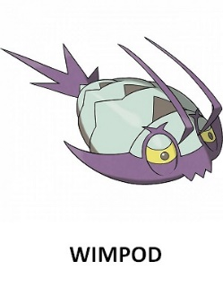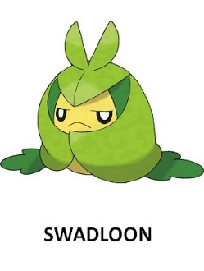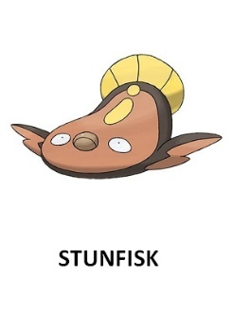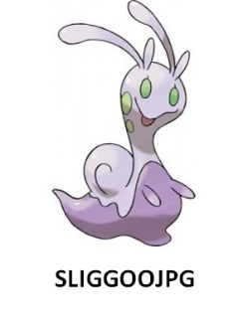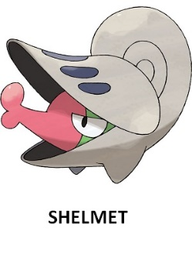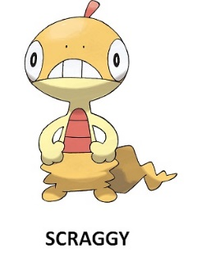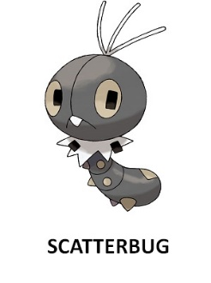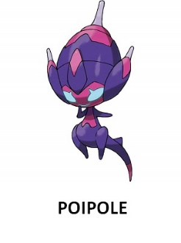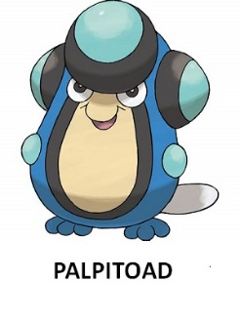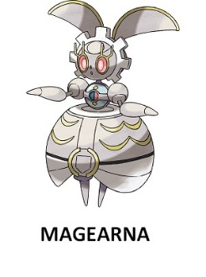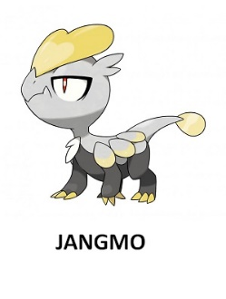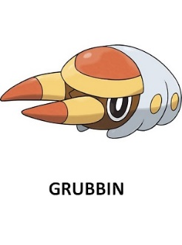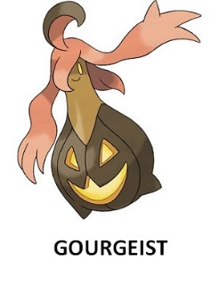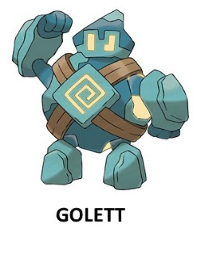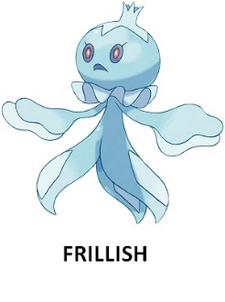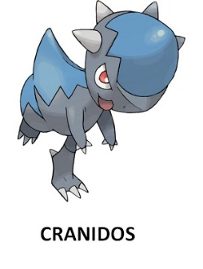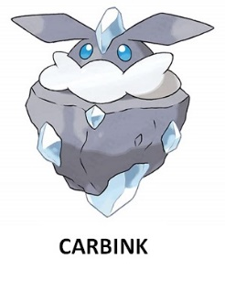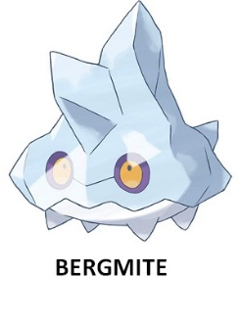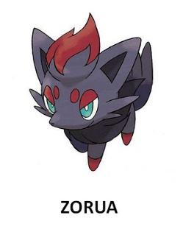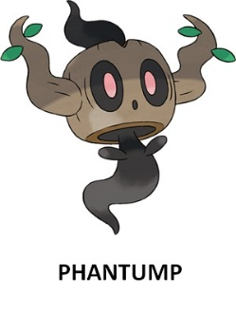

**Results:**

88 undergraduate participates completed the study in the lab (UGent). Mage = 21.52, SD = 3.90, 82% women.

|  |  |  |  |  |  |  |  |
| --- | --- | --- | --- | --- | --- | --- | --- |
| **name** | **mean_liking** | **sd_liking** | **like_d.es** | **name** | **mean_fami** | **sd_fami** | **fmi_d.es** |
| Magearna | -0.01136 | 2.098134 | 0.005416 | Magearna | 0.386364 | 1.108295 | 0.005416 |
| Zorua | 0.022727 | 2.170742 | 0.01047 | Zorua | 0.886364 | 1.796752 | 0.01047 |
| Jangmo | 0.034091 | 1.784021 | 0.019109 | Jangmo | 0.363636 | 0.860123 | 0.019109 |
| Shelmet | 0.056818 | 1.796279 | 0.031631 | Shelmet | 0.511364 | 1.144646 | 0.031631 |
| Golett | -0.14773 | 1.921085 | 0.076898 | Golett | 0.488636 | 1.017031 | 0.076898 |
| Scatterbug | 0.159091 | 1.793259 | 0.088716 | Scatterbug | 0.579545 | 1.171712 | 0.088716 |
| Cranidos | -0.30682 | 1.949701 | 0.157367 | Cranidos | 0.954545 | 2.044949 | 0.157367 |
| Swadloon | -0.375 | 1.858887 | 0.201734 | Swadloon | 0.613636 | 1.425803 | 0.201734 |
| Bergmite | 0.352273 | 1.681815 | 0.20946 | Bergmite | 0.397727 | 0.953394 | 0.20946 |
| Gourgeist | -0.77273 | 2.303058 | 0.335522 | Gourgeist | 0.465909 | 1.134099 | 0.335522 |
| Frillish | 0.625 | 1.821408 | 0.343141 | Frillish | 0.568182 | 1.311273 | 0.343141 |
| Scraggy | 0.590909 | 1.609143 | 0.36722 | Scraggy | 0.590909 | 1.301073 | 0.36722 |
| Grubbin | -0.63636 | 1.620145 | 0.392782 | Grubbin | 0.352273 | 0.844724 | 0.392782 |
| Wimpod | -0.79545 | 1.627063 | 0.48889 | Wimpod | 0.420455 | 1.025218 | 0.48889 |
| Palpitoad | 1.056818 | 2.019206 | 0.523383 | Palpitoad | 0.511364 | 1.250235 | 0.523383 |
| Carbink | 1.136364 | 1.826886 | 0.622022 | Carbink | 0.420455 | 0.931216 | 0.622022 |
| Phantump | -1.35227 | 1.881793 | 0.718609 | Phantump | 0.397727 | 1.011881 | 0.718609 |
| Sliggoo | 1.818182 | 1.962554 | 0.926436 | Sliggoo | 0.522727 | 1.312865 | 0.926436 |

The nine most neutral: Liking: t-test is for difference from zero

Familiarity: t-test is for difference from 4



Liking: t(87) = -0.05, p = 0.959, d =0.05, BF10 = 0.117

Familiarity: t(87) = -30.58, p < 0.001, d =3.26, BF10 > 1000



Liking: t(87) = 0.09, p = 0.922, d =0.01, BF10 = 0.118

Familiarity: t(87) = -16.25, p < 0.001, d =1.73, BF10 > 1000

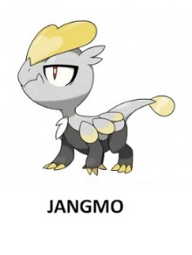

Liking: t(87) = 0.17, p = 0.858, d =0.01, BF10 = 0.119

Familiarity: t(87) = -39.66, p < 0.001, d =4.22, BF10 > 1000



Liking: t(87) = 0.29, p = 0.767, d =0.03, BF10 = 0.122

Familiarity: t(87) = -28.59, p < 0.001, d =3.04, BF10 > 1000



Liking: t(87) = -0.72, p = 0.472, d =0.07, BF10 = 0.151

Familiarity: t(87) = -32.38, p < 0.001, d =3.45, BF10 > 1000

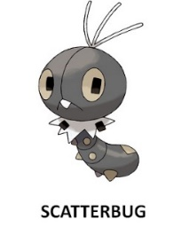

Liking: t(87) = 0.83, p = 0.407, d =0.08, BF10 = 0.164

Familiarity: t(87) = -27.38, p < 0.001, d =2.91, BF10 > 1000



Liking: t(87) = -1.47, p = 0.143, d =0.157, BF10 = 0.334

Familiarity: t(87) = -13.97, p < 0.001, d =1.48, BF10 > 1000



Liking: t(87) = -1.89, p = 0.061, d =0.20, BF10 = 0.646

Familiarity: t(87) = -22.28, p < 0.001, d =2.37, BF10 > 1000



Liking: t(87) = 1.96, p = 0.052, d =0.20, BF10 = 0.736

Familiarity: t(87) = -35.44, p < 0.001, d =3.77, BF10 > 1000

Choose CSs – I started to compare pairs of Pokémon starting from the most neutral in valence. The criteria were: no difference in valence or in familiarity (based on p-value > 0.05 from t-test and BF01 > 3). If a pair didn’t met these two criteria, I tested the next pair until the two criteria are met

**CSs will be Magearna and Jangmo**

Difference between them:

Liking: t(87) = -0.17, p= .862, d = -0.01, BF10 = 0.119, BF01 = 8.40

Familiarity: t(87) = 0.21, p= .830, d = 0.02, BF10 = 0.120, BF01 = 8.33

**Targets will be:** Bergmit, Zorua, Golett, Shelmet, Cranidos

**Fillers will be:** Scatterbug, Swadloon